life_skills

Kevin Gilds, MPA

July 20, 2016

# Life Skills

*Objective 4: 70% of participating girls will demonstrate an increased understanding of pertinent life skills as demonstrated by a pre and post assessment*

The students in Get REAL! program met this objective by

Students, parents, and teachers are asked to complete surveys at the time of enrollment in the Get REAL! program and at the end of their session. The questions in the survey are designed to measure the following life skills.

1. Healthy Relationships
2. Academic Engagement
3. Academic Mastery

The questions and the scoring methodology of the girl survey were developed and tested by the Girl Scout Research Institute. Girls answer multiple questions to obtain an outcome score for each life skill domain. Responses to survey questions are assigned numbers/points and outcome scores are calculated by averaging responses to survey questions for each category. The points for each outcome set are averaged to obtain an outcome score. Outcomes scores range from 0-6. Outcome cut points are used to determine high achievement, and they are determined by the number of questions in the outcome set and response options. Below is a breakdown of the cut points by the outcomes measured.

Life Skills Achievement Average Score to Indicate High Achievement

1. Healthy Relationships 4.45=>
2. Academic Mastery 4.8=>
3. Academic Engagement 4.5=>

There were 418 post survey responses and 330 students responses could be matched from the pre-survey to the post surey. This analysis views any increase in outcome score from the pre assessment to the post assessment or maintaining high achievement as demonstrating an understanding of a life skill.

The students demonstated increase knowledge across all life skill domains. Parent and teacher surveys also provide evidence that the students are benefiting from the program. Please note pre teacher surveys are not analyzed as only 50 were recieved.

`

## Healthy Relationship Outcome

Relationship skills are a critical component of success in all realms of life. The Healthy Relationship questions measures the behaviors and attitudes of the respondent regarding their relationship skills. Questions that measure healthy relationships skills include the following:

*Healthy Relationship Questions*

1. If I have a serious problem, I have people to talk with.
2. I let people know if they have hurt my feelings.
3. I let my friends know when I think they are good at something.
4. In any relationship - romantic or not - I make it clear when I don't feel comfortable.

The number of pre and post survey that could be matched is **330**, and the percent of students with a successful outcome is **84.85%**

1. The number of students who achieved at a high level is **257**:
2. The number of studens who did not achieve at high level but increased outcome socre **23**:

The improvement in outcome scores is graphically represented below.

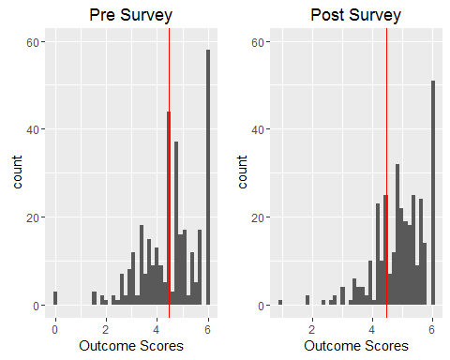

The percent of students who achieved the healthy releationship at a high level is **77.88%**. The imrovement is represented graphically below.

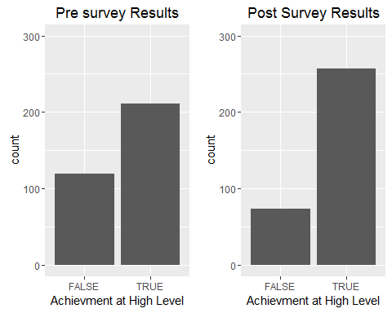

The percent of students who went from low achievment to high achievement **26.67%**. The number of students who had the opportunity to improve their healthy relationship outcome score is **238**, and the mean increase in outcome score is **0.5244748**

The increase in the healthy relationship outcome scores is represented graphically below. Marks to the right of the veticial red line represents an increase in the outcome score. Marks above the horizintal line represents scores above the high and low achievement.

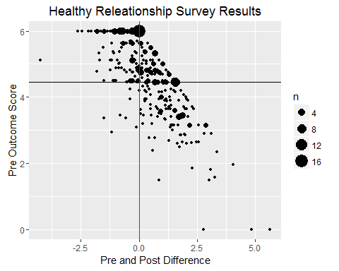

Two statisical tests were administered on the matched survey results the wilcox test and Cohen's D test.

The outcome distributions did not approximate a normal distribution, thus A wilcox.test was administered and the results show that the difference between the pre and post outcome scores are significant at 05 level.

Wilcoxon rank sum test with continuity correction: hr_2016$Pre and hr_2016$Post

|  |  |  |
| --- | --- | --- |
| Test statistic | P value | Alternative hypothesis |
| 42887 | 1.101e-06 * * * | less |

The Cohen D test indicates that the effect was small.

##   
## Cohen's d  
##   
## d estimate: 0.3316444 (small)  
## 95 percent confidence interval:  
## inf sup   
## 0.1774961 0.4857928

## Cross Validation of Healthy Relationship Skills

Survey results from teachers and parents also provide evidence that the Get REAL! program helps students increase their relationship skills. Below are tables that provide a breakdown of questions on the post survey from the parent and teacher surveys. The pattern again shows improvement in moderate agreement with the question being both with the parent survey and teacher survey.

### Pre Parent Survey

* Quetion 1:She develops positive relationships with her classmates.

Results based on 466 responses.

## Item low neutral high mean sd  
## 1 Q5 1.502146 9.44206 89.05579 6.321888 1.042863

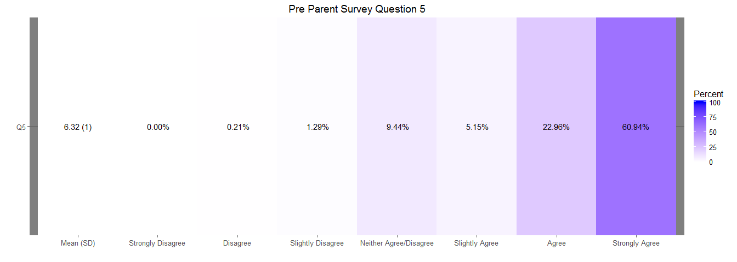

### Post Parent Survey

* Question 5: She develops positive relationships with her classmates
* Question 9: The Get REAL! program helped my daughter establish positive relationships with her classmates

## Item low neutral high mean sd  
## 2 Q9 0.4132231 0.4132231 99.17355 6.706612 0.5547584  
## 1 Q5 0.8230453 1.6460905 97.53086 6.514403 0.7292575

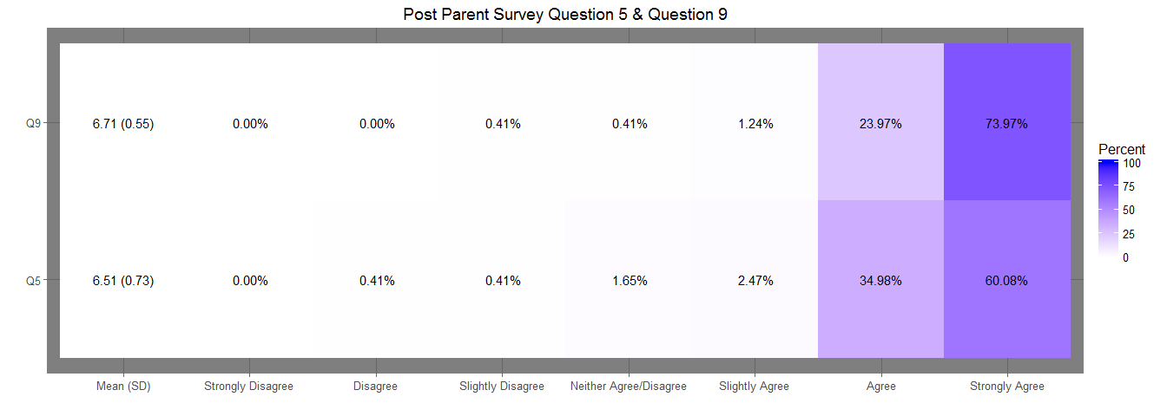

### Teacher Post Survey

* Question 7: She has developed positive relationships with her classmates (N=397)
* Question 10: The Get REAL! program helped her develop positive relationships with classmates. (N=394)

Results based on 397 responses.

## Item low neutral high mean sd  
## 1 Q7 0 1.259446 98.74055 6.463476 0.6250665  
## 2 Q10 0 2.791878 97.20812 6.624365 0.6623385

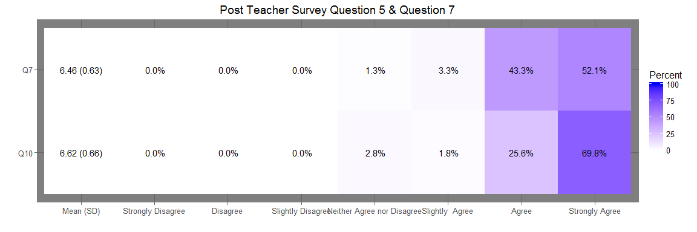

### Healthy Relationships Outcome Distribution , Plots

# Academic Engagement

Academic Engagement questions gauge tangible behaviors that help students succeed in school. Questions that measure Academic Engagement include the following. Number Question 1. I talk with my teachers before or after school, or during lunch about my assignments. 2. I hand in my assignments on time 3. I finish my homework even if it is boring 4. If I can't understand my schoolwork at first, I keep trying until I do understand it.

The number of pre and post survey that could be matched is **330**,and the percent of students with a successful outcome is **80.61%**

1. The number of students achieving the academic engagment outcome at a high level is **238**
2. The number of students who did not achieve outcome at high level but increased their outcome score is **28**

The improvement in outcome scores is graphically represented below.

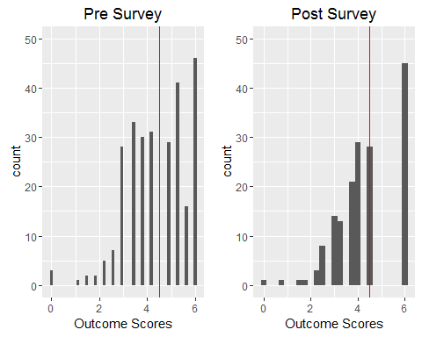

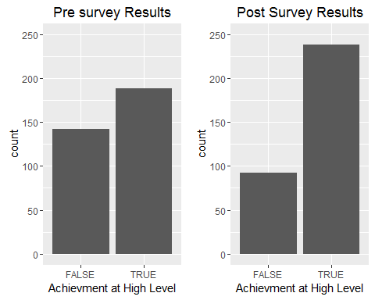

The percent of students who went from low achievement to hig achievement is **25.76%** The number of students who had the opportunity to improve their academic engagement outcome score is **256**, and their mean increase in outcome score is **0.4423828**

The increase in the academic engagement outcome scores is represented graphically below. Marks to the right of the veticial red line represents an increase in the outcome score. Marks above the horizintal line represents scores above the high and low achievement.

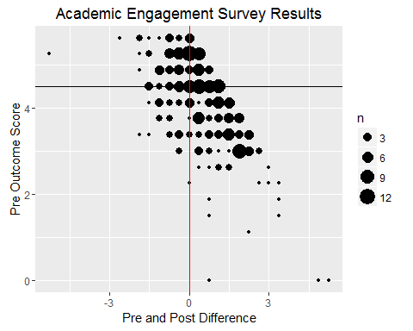

Two statisical tests were administered on the matched survey results the wilcox test and Cohen's D test.

The outcome distributions did not approximate a normal distribution, thus A wilcox.test was administered and the results show that the difference between the pre and post outcome scores are significant at 05 level.

Wilcoxon signed rank test with continuity correction: ae_2016$Pre and ae_2016$Post

|  |  |  |
| --- | --- | --- |
| Test statistic | P value | Alternative hypothesis |
| 11932 | 1.163e-08 * * * | less |

The Cohen D test indicates that the effect was small.

##   
## Cohen's d  
##   
## d estimate: -0.3133395 (small)  
## 95 percent confidence interval:  
## inf sup   
## -0.4673752 -0.1593037

## Cross Validation of Academic Engagment

Survey results from teachers and parents also provide evidence that the Get REAL! program helps students learn tangible tools to help them succeed in school. Below are tables that provide a breakdown of questions on the post survey from the parent and teacher surveys. The pattern again shows improvement in moderate agreement with the question being both with the parent survey and teacher survey.

### Parent Pre Survey:

* Question 6: She works on her homework at home without supervision (N=465)

## Item low neutral high mean sd  
## 1 Q6 1.72043 8.602151 89.67742 6.352688 1.102661

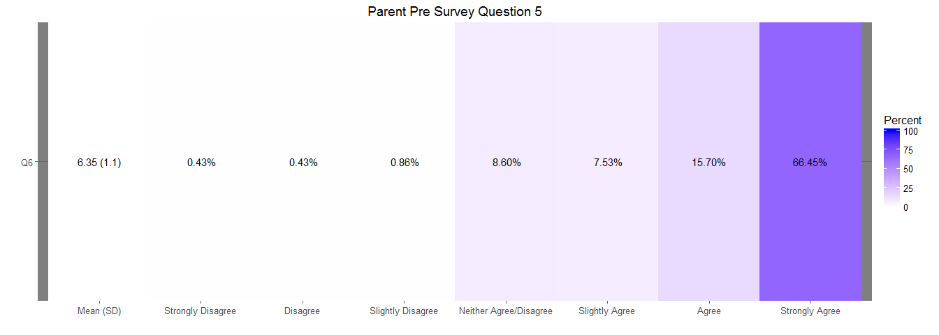

### Post Parent Survey

* Question 6: She works on her homework at home without supervision (N=244)

## Item low neutral high mean sd  
## 1 Q6 1.234568 0 98.76543 6.584362 0.7413985

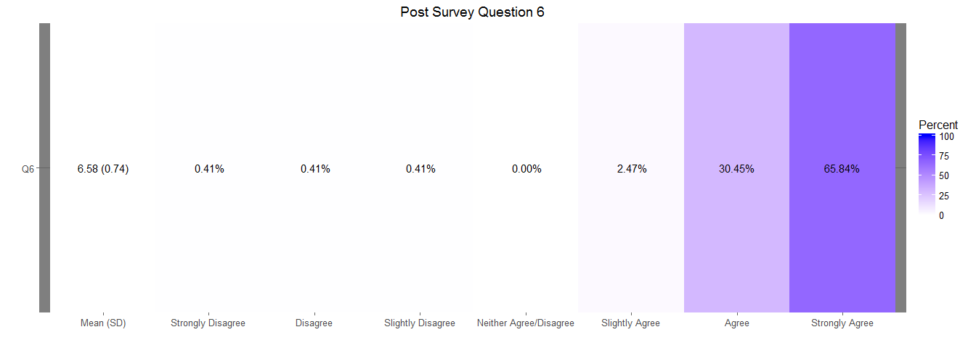

### Teacher Post Survey

Only post teacher survey data is reported as there were less than 50 responses to the pre teacher survey.

* Question 5: She positively participates in class
* Question 6: She completes the homework given to her.

Results based on 397 responses.

## Item low neutral high mean sd  
## 1 Q5 0.5037783 0.7556675 98.74055 6.405542 0.7136968  
## 2 Q6 0.7556675 0.7556675 98.48866 6.370277 0.7729147

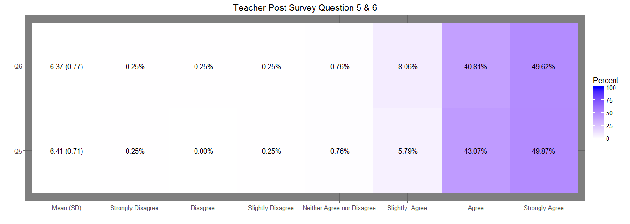

# Academic Mastery

The Academic Mastery questions gauge a student's attitude towards school and education. Questions that measure Academic Mastery include the following.

* It's important to me that I improve my skills this year in school
* It's important to me that I really understand my class work
* Learning at school is important to me
* One of my goals in school is to learn as much as I can
* The things I am learning in school will help me later in life

The number of pre and post survey that could be matched is **330**, and the percent of students with a successful outcome is **88.79%**

1. The number of students achieving the academic engagment outcome at a high level is **282**
2. The number of students who did not achieve outcome at high level but increased their outcome score is **11**

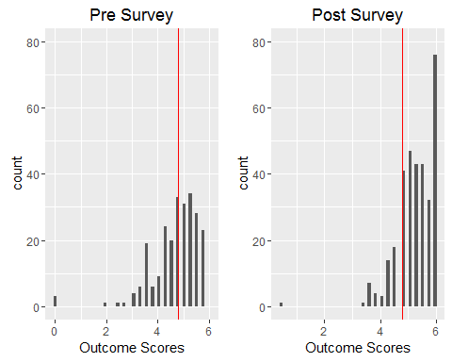

The improvement in outcome scores is graphically represented below.

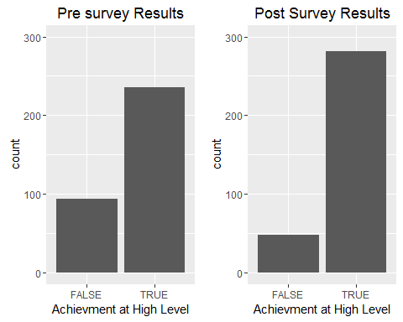

The percent of students who went from low achievement to hig achievement is **24.24%** The number of students who had the opportunity to improve their academic engagement outcome score is **200**, and their mean increase in outcome score is **0.4092**

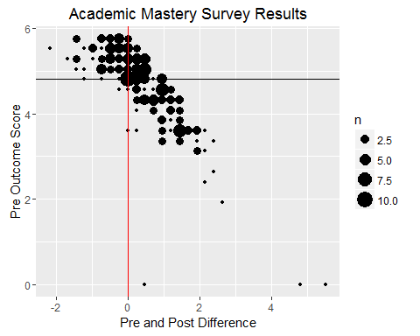

### Statistical Tests

Two statisical tests were administered on the matched survey results the wilcox test and Cohen's D test.

The outcome distributions did not approximate a normal distribution, thus a wilcox.test was administered and the results show that the difference between the pre and post outcome scores are significant at .05 level.

Wilcoxon signed rank test with continuity correction: am_2016$Pre and am_2016$Post

|  |  |  |
| --- | --- | --- |
| Test statistic | P value | Alternative hypothesis |
| 13671 | 0.0001128 * * * | less |

The Cohen D test indicates that the effect was small.

##   
## Cohen's d  
##   
## d estimate: -0.2181761 (small)  
## 95 percent confidence interval:  
## inf sup   
## -0.37172858 -0.06462362

## Cross Validation of Academic Mastery

Survey results from teachers and parents also provide evidence that the Get REAL! program helps students formulate better attitude toward school. Below are tables that provide a breakdown of questions on the post survey from the parent and teacher surveys. The pattern again shows improvement in moderate agreement with the question being both with the parent survey and teacher survey.

#### Pre Parent Survey

* Question 1: She is motivated to graduate high school
* Question 3: She has a Good Attitude About School

Results based on 466 respones.

## Item low neutral high mean sd  
## 2 Q3 0.6437768 2.360515 96.99571 6.510730 0.7957499  
## 1 Q1 0.2145923 7.296137 92.48927 6.630901 0.8829508

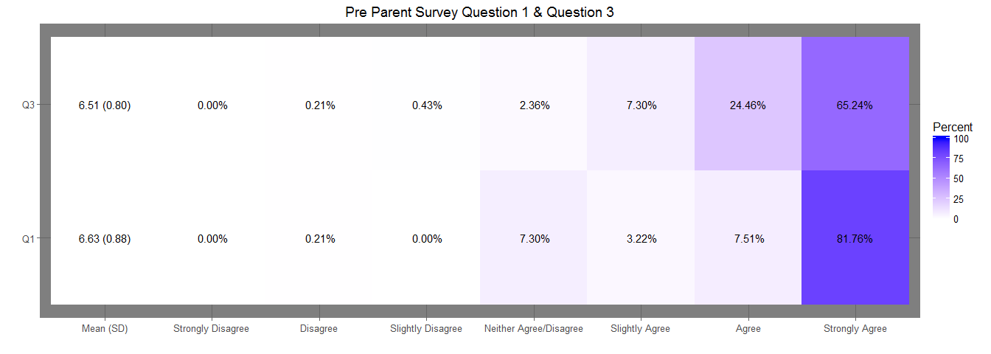

### Post Parent Survey

* Question 1: She is motivated to graduate high school
* Question 3: She has a Good Attitude About School

Results based on 244 responses.

## Item low neutral high mean sd  
## 1 Q1 0.000000 1.2345679 98.76543 6.522634 0.6253115  
## 2 Q3 1.234568 0.8230453 97.94239 6.481481 0.7784989

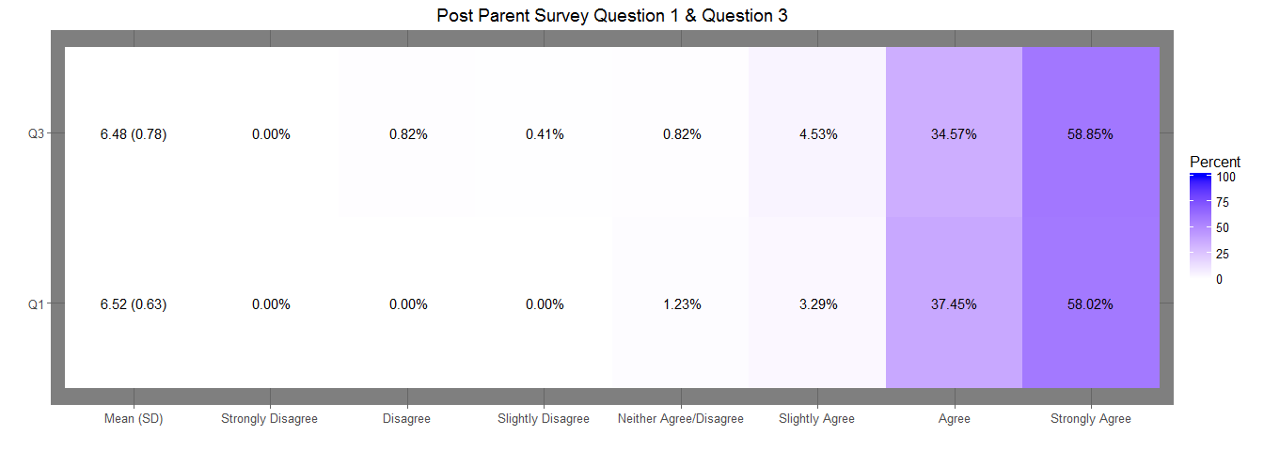

### Teacher Post Survey

* Question 1: She is motivated to graduate high school
* Question 3: She has a Good Attitude About School

The number of responses to the post teacher survey is 397.

## Item low neutral high mean sd  
## 1 Q1 0.2518892 1.007557 98.74055 6.465995 0.6643728  
## 2 Q3 0.7556675 1.259446 97.98489 6.365239 0.7142848

